# Dramatic Tools

## Theme

* Japan 1500 – 1600 (approx.)
* Civil war
* Age of samurai (nowadays glorified as honorable warriors)
* *Beautiful Japanese architecture and culture + brutal, merciless war*
* Generations have known nothing but war
* ***‘People fight for peace’***
* *‘Don’t show them mercy as they will show non to you’*
* Warlords (‘Daimyos’) who are not afraid to sacrifice their people for power
* 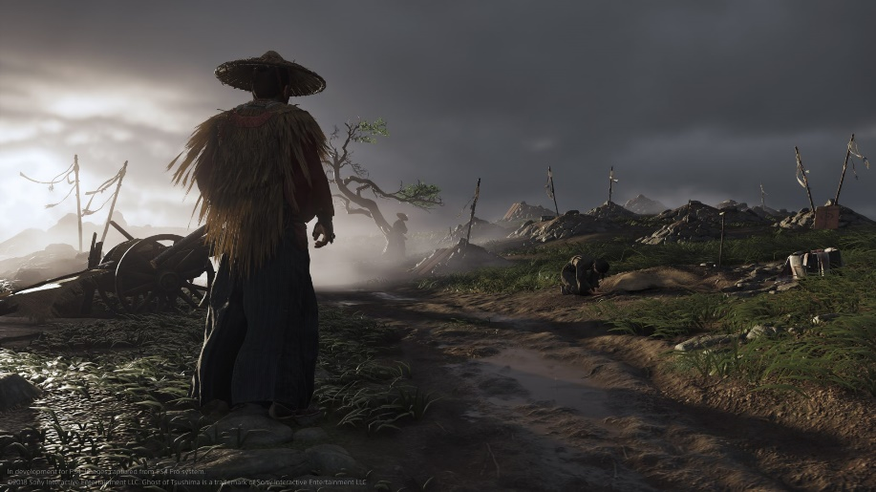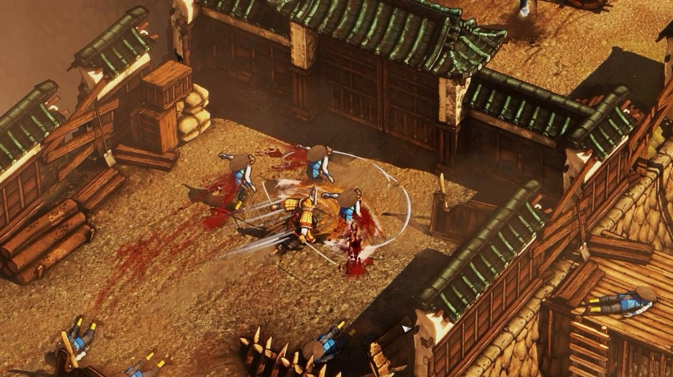Fight for survival vs. living a honorable life

## Mood

* Warlords get more powerful in exchange for suffering of their people (mostly for civilians)
* Justified by the honor & glory of fighting and dying for their lords
* Huge armies and mighty castles vs. battered villages and poor peasants
* A permanent conflict between the ideology of believing in the existence of a code of honor vs the decay of all moral standards after generations of people have known nothing but war
* 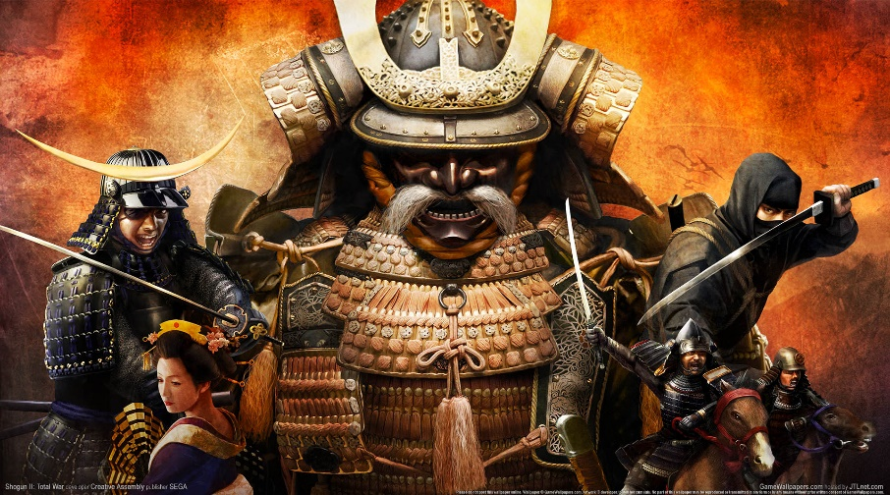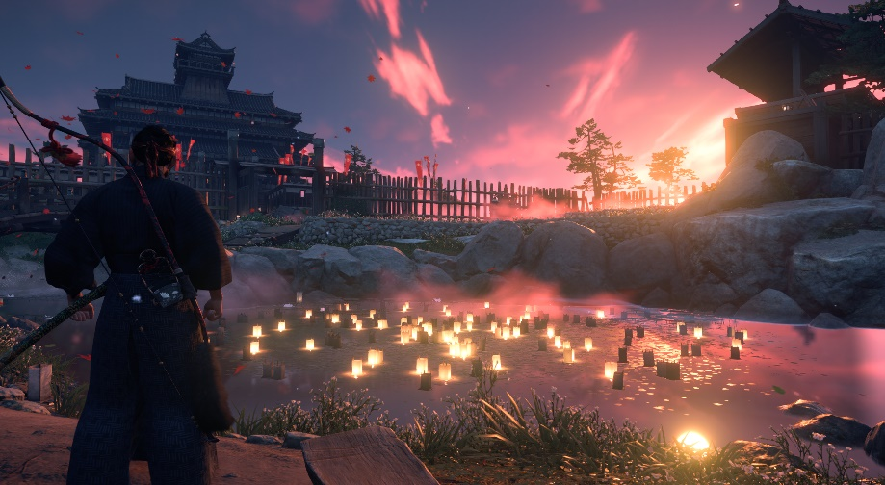Tradition are being overthrown by new types of warfare (e.g. night attacks have never been used as a meaning of warfare; introductions of arquebus vs the traditional samurai warfare)

## Form & Style

|  |  |
| --- | --- |
| Form | Style |
| Discussions of characters (NPCs) in the level | Display of different opinions on the war (NPCs talking about hopes, dreams, family, etc.) – make it a tough decision to take someone’s life |
| People (prisoners) being executed | “War will make corpses of us all.” (Faramir, LotR), Soldiers who have dreams and hopes themselves have no mercy for the other side |
| General giving a great speech about the honor of fighting for the enemy clan | Enemy soldiers seem to have pretty much the same motivation to fight for their lord as the main character |
| Inner monologues of the character throughout the levels | Display the inner conflicts of the character |
| Banners and colors of the local clan | Strengthen feeling of being in enemy/friendly territory |
| Civilians being abused and raided from all sides | Suffering of the poorest is worth it for a higher good? |

## Plot

Throughout the first act the character (Hattori Hanzo) will form a stronger bond with his lord (Ieyasu Tokugawa), feeling that he is a Daimyo, that is different from the others and who is trying to protect his people by forming alliances. This is also the act that is currently described in the beat chart.

It starts of with the destruction of Hanzo’s home village and the survivors being secured by Ieyasus father. This establishes the characters great longing for peace as he has suffered indescribable losses while also forming a strong bond of duty towards the Tokugawa clan as they saved his life.

After that comes the introduction to the Tokugawa castle which should give a real feel of safety (kids playing, well-protected civilians, peaceful atmosphere) and is something that he will want to protect in the future. Also, this will serve as a base for most of the game and should become something like a new home though it might be taken away from him somewhere throughout the game to amplify the characters internal crisis.

The 3rd level then introduces Ieyasu, who is held captive at a temple of the enemy clan (Oda). Hanzo is send by Ieyasus father (currently dying) who fears that he might be killed by the Oda when the Imagawa (allies) attack the castle as a meaning of ‘burned soil’ but Ieyasu refuses as he believes that if he flees the Imagawa might not believe in their alliance. Instead, he hopes to be ‘rescued’ by the Imagawa and through that establish an alliance with them after his father’s death (as they feel that he is in their debt) and through that give more protection to his future people. This should be the base of Hanzo’s believe in Ieyasu as he knows that Ieyasu is ready to risk his own life for his people.

The 4th level will be a few years later (maybe some other missions can be inserted before it to further form the bond between Hanzo and his master) and will be part of the campaign of the Imagawa, supported by Ieyasu and his clan. Hanzo has the goal to spread some disinformation between the Oda leader and his subordinates to make the siege of a border castle for Ieyasu and his men easier. He will start of with the feeling of getting a long-awaited revenge as his mission is to exchange a letter to the castles commander who is supposed to defend the castle until the Oda forces can come to support them but instead the exchanged letter will order him to leave the castle and come to the Oda military camp. Ieyasus hope is to ambush them then on the way and by that eliminating the Oda forces without their defences. Hanzo will be happy to do that at first as the castles commander is the same one who has raided his village years ago. Throughout the level however Hanzo will come to know that there are also a lot of civilians in the border castle who will travel along with the troops and will be killed in the ambush. This will start the inner conflict of what is needed vs what is honorable.

The 5th and final level of the first act (again some levels could be inserted before that to further illustrate the bond between Ieyasu and Hanzo but also to amplify his inner conflict) will be a turning point of the campaign as the Imagawa forces are resting in a gorge, preparing to take the last Oda castle. During the night, the soldiers are celebrating the close by victory and Hanzo (who is in the camp as an emissary and to inform Ieyasu, who is in a close by border fortress, when the troops are making ready for attack on the next day) overhears some discussions that make him doubt that these soldiers are much different and more honorable than the Oda soldiers. Then, the camp is attacked out of the dark by the remaining Oda forces. It is mayhem and as the Imagawa forces are being slaughtered and routing, Hanzo has to escape. After the Imagawa have been crushed, Ieyasu switches sides and the Oda Nobunaga becomes his new ally and superior.

In the second act this bond will be put on the test when he must perform more and more critical missions that are aimed for a higher good. These missions though ordered by Ieyasu come from higher authorities and are more kind of a compromise between the lust for power of Ieyasus superiors and his goal to protect his people by not causing his superiors anger and distrust. Hanzo will see a change of Ieyasus character as he seems to become more and more hungry for power though it’s justified that only more power for Ieyasu can protect his people from the growing dangers

In the final act this change of character will become completed as Ieyasu rises to enormous power and while Hanzo sees that Ieyasu could be the one to unify Japan, he questions more and more on what cost this happens.

## Pacing

The goal is to achieve a pacing that makes the player understand that his lord has good intentions but question more and more whether this is the right way. As mentioned in the Form & Style chapter this conflict is created by knowing that the characters actions serve a higher good while facing a reality in which **opposing sides fight each other** as they are **trying to achieve basically the same thing.**

Though there are different ways to approach a level with different ability types (e.g. distracting enemies vs stealth-killing them vs finding ways around them, like secret passages), the pacing should always be linked to a feeling that every action has consequences. The player should be able to have an impact on the pacing by using mechanics to their advance. For example, using the mechanic of disguising as an enemy may make the player less flexible as their abilities change according to the character they disguised as and by that increases the pace because they can walk by some enemies and get through the level faster but must fear that they are caught in a more difficult situations with bad equipment and abilities (should give some adrenalin).

In general, however the game aims for a slow pace to underline the things happening around the character and relating to the fact that the game is a stealth game in the first place. Good planning of the players actions is promoted and should be rewarded in contrast to running through the levels and acting like a slaughtering hobo. After all the player is not some overpowered hero that can easily take on fighting multiple enemies at the same time, they may be a well-trained ninja but that means acting cautiously and not drawing to much attention – even better not causing any commotion at all.

# Visual experience

## Image result for shadow tacticsMoodboard

## Image result for ninja stealth gameImage result for shadow tacticsImage result for sengoku jidaiImage result for sengoku jidaiImage result for sengoku jidaiImage result for shadow tacticsVisuals

In general, the game should have an art style similar to games like “Desperados” or “Shadow Tactics”. This could be described as a closely realistic art style with painting elements (much like in other anime games). This is supposed to achieve a mixture that gives everything a feeling of the character telling his story in a Japanese manner.

While having a good part of the missions being carried out in the dark to imply the need of secrecy and give an imminent feeling of danger there will be also be a good part of daylight missions. These missions are thought to show the daily life in the castles and villages and display that even though these people are enemies, they are not different. The goal is to show that they are facing the same issues of injustice, suffering from war, etc.

When carrying out night-time missions the use of light and darkness will also contribute as a strategic factor, which means that darkness can offer some form of hiding options but can also be an obstacle as the character obviously does not have night vision. As in most stealth games it will also serve as an option to confuse enemies etc. On the one hand this means that the player will most likely avoid walking in light cones as they reveal him to the surrounding but on the other hand, they sometimes will need the light as well, for example he won’t be able to read a map in the darkness and performing actions like breaking a lock has a lower chance of success when performing it in the dark.